The GENESIS Project

This is a one-hour session structured as follows:
Time | Activity
7 minutes | Read the case exercise individually
8 minutes | Discuss the cases with small group (3-4)
30 minutes | Panel members comment on the decisions
15 minutes | Panel members answer audience questions

It is calendar year 2000. NASA has just experienced two Mars mission failures and is grappling with the balance between risk and reward in implementing low cost missions.

The GENESIS Mission

The Genesis Project was proposed and selected as the fifth in NASA’s series of Discovery missions to be executed in the PI mode. The purpose of the mission is to collect samples of solar wind and return them to Earth. Professor Don Burnett of the California Institute of Technology (CIT) is the principal investigator and project team leader. The Jet Propulsion Laboratory (JPL) is the managing agency and provides the science canister. Los Alamos National Laboratory (LANL) provides the electrostatic concentrator for the science canister and the Electron and Ion Monitors. Lockheed Martin Aeronautics (LMA) is the industrial partner and provides the spacecraft and Sample Return Capsule (SRC). JPL and LMA will conduct mission operations. Genesis is an immediate development successor to the Stardust mission which used a similar spacecraft and sample return capsule, and was designed to return samples of Comet Wild-2. Stardust was also built in partnership between the JPL and LMA. Genesis was justified as low risk and with reduced costs based on its heritage from Stardust, even though Stardust will not return to Earth for more than a year after Genesis. See Figure 1 for the organizational structure of the project.
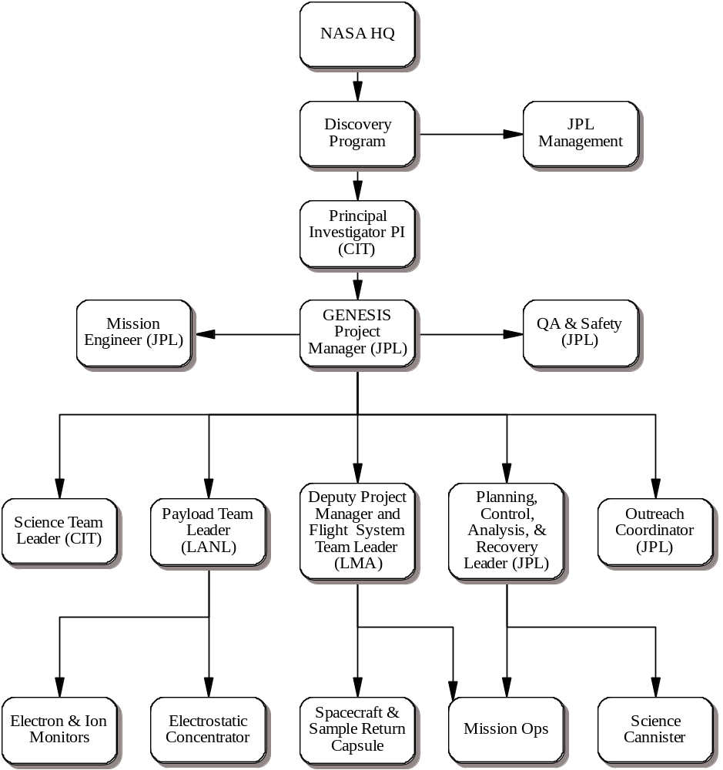

Figure 1 Organizational Responsibility

The Mission Design
Genesis will provide fundamental data to help scientists understand the formation of our solar system, reinterpret data from past space missions, and provide focus to many future missions. Analysis of the collector materials will give precise data on the chemical and isotopic composition of the solar wind. Genesis will be positioned approximately 1.5 million kilometers from the Earth orbiting the Earth-Sun libration point L1 which is outside Earth’s magnetosphere. It will remain in a libration point orbit for at least two years. The spacecraft will be returned for a day-time Earth entry with the objective of providing a soft landing for the science samples while protecting them from contamination.

The spin-stabilized spacecraft is composed of a main spacecraft with an attached SRC, see Figure 2. As part of the sample return sequence the SRC will be separated from the main spacecraft, which will be diverted to a disposal orbit.

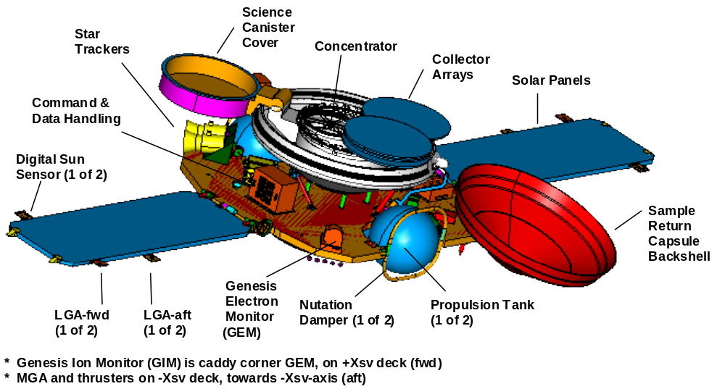

Figure 2 Spacecraft in science collection configuration, sun view.

Bringing a Sample Back to Earth
A mission failure will occur if the sample capsule cannot be opened on orbit, or if the sample collector arrays cannot be stowed and the backshell cover closed prior to earth return. One of the interesting parts of the mission is the recovery plan since it is the first U.S. mission since Apollo to return extraterrestrial material to Earth for study. The recovery involves systems on board, on the ground and ‘in air’ using a helicopter mid-air capture. The recovery process centers around safely and securely returning the SRC (sample return capsule) to the surface of the earth.

A cross section of the SRC design is shown in Figure 3. The science canister is in the center with the SRC Avionics Units (AU) and the SRC primary LiSO₂ battery mounted in the annulus around the science canister. The canister and the avionics decks are mounted to the heatshield structure. The backshell contains the drogue parachute on the centerline, and the parafoil main parachute is packed around the drogue canister. A mortar is fired inside the drogue canister to propel the drogue parachute out through the mortar cover. The Deployable Aft Conical Section (DACS), is released by firing three frangible pyrotechnic bolts (DACS Retention and Release Mechanism) and the drag load on the drogue parachute pulls the parafoil out, taking the DACS with it. Before releasing the DACS, the cable to the drogue mortar is cut with a pyrotechnic cable cutter.

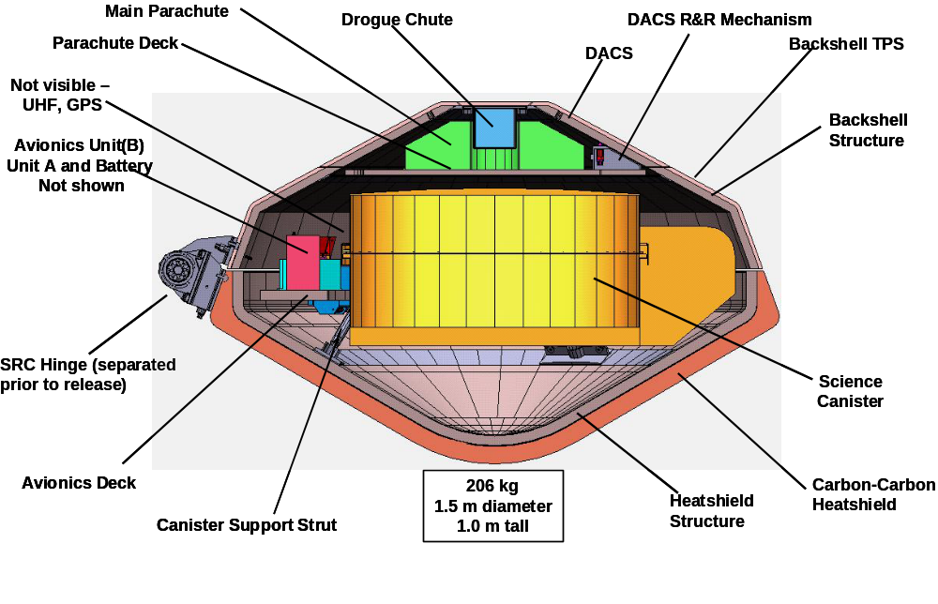
Figure 3. SRC cross-section (SRC hinge is separated from SRC prior to release).

Drogue and Parafoil Parachute Deployment System Description
Approximately 8 hours prior to landing, the SRC will be prepared for separation and entry by activating (depassivating) its dedicated batteries, severing umbilicals, and increasing the spacecraft rate of rotation. A 4-hour period had been designed into the timeline to permit response to any observed contingency prior to separation from the parent Genesis spacecraft.

Following separation, the SRC will continue on a ballistic trajectory to its entry interface with the Earth’s atmosphere. Following separation, the SRC is completely passive until activation of the drogue/parachute deployment sequence. Mission success can only be expected if the SRC follows the proper trajectory and if the drogue and parachute are deployed at the proper time, allowing aerial capture by the helicopters and a soft recovery. Figure 4 illustrates the nominal timeline from the SRC release enable/no-go decision through landing. Figure 5 is a photo of the helicopter snatch in a practice run.

SRC Entry
E=0H (09:53 MDT, 15:53 UTC)
V = 11 km/s
FPA=-8.0°
5th Helicopter Pass (if required) E+23m, 1.4km
ALTITUDE
DOWNRANGE
SRC Release Enable/No Go
E-8H
SRC Separation
E-4H
125 km
Atmosphere
Earliest UTTR Radar Acquisition ~E+1.5m, ~60km
Drogue Deploy E+2.2m, 33km
Begin 1st Helicopter Pass E+19m, 2.5km
Parafoil Deploy E+6.5m, 6.7km
Nominal UTTR Radar Acquisition ~E+3.5m ~22km
Helicopter Intercept SRC E+18m, 2.8km
Over UTTR Airspace ~E+1.6m, ~43km
Earliest STRATCOM (Altair)
~E-4:14, ~60,000km
Nom. STRATCOM (Altair)
~E-1:40, ~32,000km
Nom. End STRATCOM (Beale)
SYSTEM X
Figure 5. Entry timeline.

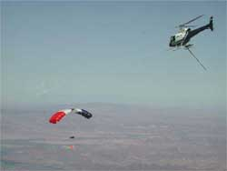

Figure 5 Helicopter Recovery

Your Decision: How to be sure Genesis succeeds
You are the Discovery Program Manager. At this time, the Genesis Project is undergoing final system assembly and is almost ready to begin its environmental test program. Because of the catastrophic failures of two recent Mars Missions, both managed by your employer, the NASA Jet Propulsion Laboratory and both built by your partner, Lockheed Martin Astronautics in Denver, Colorado, NASA Headquarters and your management are concerned that there may be mission threatening problems in the Genesis Mission System as well.

Your assignment is to decide what if anything needs to be done to assure mission success ensuring that the precious science samples are returned safely to earth. While the mission was selected and confirmed under the “faster, better, cheaper” philosophy, the Agency has since become more risk averse.

From the initial assessment of the Project status and discussions with the Project Manager, you make the following observations:
- Your Genesis team is in competition with the Mars Odyssey Mission for personnel and facilities resources at both the JPL and LMA and launch resources at the KSC.
- Genesis has launch opportunities for two weeks in each of three consecutive months, twice per year; missing a sequence of windows means a 3+ month slip to the next window.
- Few of the JPL team members worked on Stardust. The LMA project team is a mix of people with direct experience on Stardust (some in more responsible positions than before), as well as new people.
- Also because of the expected benefits of heritage and based on a ‘lesson learned’ from Stardust that some system engineers were not effectively deployed, your total systems engineering team is about 25% smaller than that employed on its predecessor Stardust.
- Because of the faster/better/cheaper philosophy of sharing responsibility and authority, and allowing each organization to use its own processes with substantial autonomy, your JPL staff has focused primarily on the development and qualification of the payload, flight operations, navigation, and the entry and recovery operations, meanwhile the LMA staff has focused primarily on the development of the spacecraft and SRC;
- You have sufficient resources to call on additional JPL experts when you identify a specific problem or concern.

You have a range of options to be considered but they must be justified to your Management and NASA Headquarters in terms of the reductions in risk versus the resources expended. Options you might consider include:
- additional reviews (define who, how, when, how long, one time vs repetitive, needed follow-up etc)
- deployment of additional outside experts to join the team
- additional tests
- stand downs within the team to review progress and decisions made
- others TBD
Discuss your options and likely actions with several others and then be prepared to share your perspectives with the larger group.

